Dulce et Decorum Est

Bent double, like old beggars under sacks,
Knock-kneed, coughing like hags, we cursed through sludge,
Till on the haunting flares we turned our backs,
And towards our distant rest began to trudge.
Men marched asleep. Many had lost their boots,
But limped on, blood-shod. All went lame, all blind;
Drunk with fatigue; deaf even to the hoots
Of gas-shells dropping softly behind.

Gas! GAS! Quick, boys! — An ecstasy of fumbling,
Fitting the clumsy helmets just in time,
But someone still was yelling out and stumbling
And floundering like a man in fire or lime. —
Dim through the misty panes and thick green light,
As under a green sea, I saw him drowning.

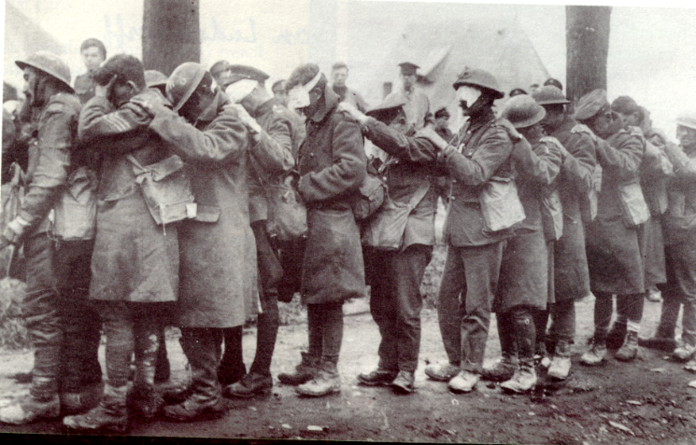
In all my dreams before my helpless sight
He plunges at me, guttering, choking, drowning.

If in some smothering dreams, you too could pace
Behind the wagon that we flung him in,
And watch the white eyes writhing in his face,
His hanging face, like a devil’s sick of sin;
If you could hear, at every jolt, the blood
Come gargling from the froth-corrupted lungs,
Bitter as the cud
Of vile, incurable sores on innocent tongues, —
My friend, you would not tell with such high zest
To children ardent for some desperate glory,
The old lie: Dulce et decorum est
Pro patria mori.
Wilfred Owen

- Which words and comparisons do you find especially forceful and interesting?

- What does “blood-shod” mean?

- In the second section, green fumes of poison gas spread round the men. What strange comparison is used to describe them in the gas?

- Why does one man die? What do the others do with him?

- The poem was written for a female journalist Jessie Pope (an English poet, writer and journalist, who remains best known for her patriotic motivational poems published during WWI). The ‘you’ in the poem refers to her. What exactly is the writer’s message for her?

